**BRANDING GUIDELINE FOR VIDEO PRODUCTION**

This short guideline provides orientation to anyone producing a video for AVANTI. It is an example that you can adapt to your initiative.

**3-STEP GUIDELINE**

1. **INTRO LOGO.** Every video of AVANTI should start with the logo of AVANTI with the following characteristics:
   1. White background
   2. Use logo language according to context (english, french or spanish)
   3. Logo should appear for about 3 seconds
   4. Logo should be located as instructed in the image below: divide screen horizontally in 3 blocks, and ensure the traingle starts at the begining of the third block.

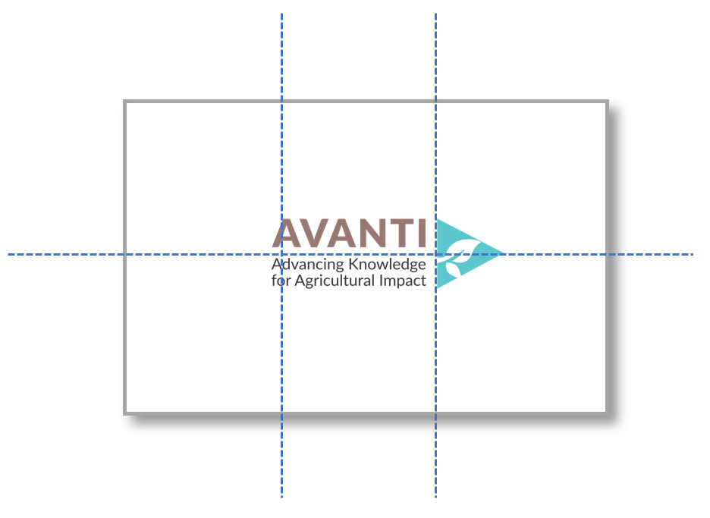

1. **THE CONTENT** of the video should comply with the following:
   1. Videos or images should not be blurry
   2. If video shows people, the video or images should be mostly pro-active (e.g. show people working together, in dialogue, engaged in conversations).
   3. If video includes an interview, use the composition of 3 blocks to position the subject in the between two blocks (avod placing people in the center). See example:



* 1. Text (for content or subtitles) should be in Font “lato”.
  2. Other graphics: use a triangular or diagonal shape when posible, and use the Brand colors (see “brand visual guidelines” in the rerources below).
  3. Music: if you want to add background music, use the licensed music track “The Journey” (see resources below).

1. **CLOSING INFORMATION.** The last shot or slide in the video should be again the logo as shown in the intro slide, plus identity and contact information below. The informatoin to be added can be:

*Learn more about AVANTI and subscribe to our newsletter at* [*www.avantiagriculture.org*](http://www.avantiagriculture.org)

*Day, Month, Year (e.g. 4 September 2018)*

See example

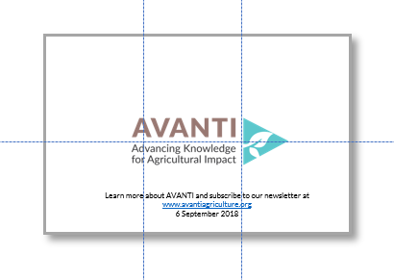

**RESOURCES**

* Font: <https://fonts.google.com/specimen/Lato?selection.family=Lato>