Insert official country/ministry logo

Country xx AG-Scan Action Plan

Month, Year

TABLE OF CONTENTS
Abbreviations and Acronyms 3
Executive Summary 4
1.0 Introduction 5
1.1 Methodology 5
2.0 The Status of RBM Capacity in the Five Pillars and Gaps Identified 7
2.1 Leadership 7
2.2 Evaluation and monitoring 9
2.3 Accountability and partnership 11
2.4 Planning and budgeting 12
2.5 Statistics 13
3.0 Overarching Lessons Learned 15
3.1 Coordination 16
3.2 Capacity and skills building 16
3.3 Accountability 16
3.4 Improving M&E systems 17
4.0 Objectives of the Action Plan 17
5.0 Proposed Interventions to Strengthen M&E and RBM 18
5.1 Short Term Priority Interventions Immediately Implementable 22
6.0 Financing the Action Plan 27
6.1 Financing Options 27
6.2 Annual Ministerial Budgets 27
6.3 International Development Partners 27
6.4 Public-Private Partnership (PPP) 28
7.0 Monitoring of Plan Implementation 28

List of Tables
Table 1: Summary of the AG-Scan Pillars………………………………………………………………………………………6
Table 2. Interventions Proposed for the Short, Medium, and Long Term……………………………………..…18
Table 3. Short Term Priority Interventions………………………………………………………………………………….23
List of Figures
Figure 1: Scoring Criteria for the Five Ag-Scan Pillars…………..………………………………………………………..6
Figure 2. Summary of LEAPS Scores………………………………………………………………………………………….…15

Abbreviations and Acronyms

Executive Summary

1.0 Introduction

1.1 Methodology
Insert relevant text

Table 1: Summary of the AG-Scan Pillars
RBM Pillar | Descriptor
- Leadership | The interest, commitment and political will shown by decision makers and senior management in promoting a culture of results, and evidence-based decision making
- Evaluation & Monitoring | The extent to which the sector makes use of monitoring and evaluation functions in decision making, management and accountability?
- Accountability & Partnerships | Assessment of accountability and transparency by government to citizens and partners and vice versa
- Planning & Budgeting | The extent to which the government makes use of data results in planning and budget formulation.
- Statistics | The quality, quantity, and availability of data and information necessary to inform effective decision-making processes.

Each pillar is divided into several sub-categories and scores are assigned to each based on a four-point scale (1. being awareness of the issue; 2. exploring the issue; 3. representing transition towards full implementation; and 4. reflecting full implementation) as elaborated in Figure 1 below.
Figure 1: Scoring Criteria for the Five Ag-Scan Pillars
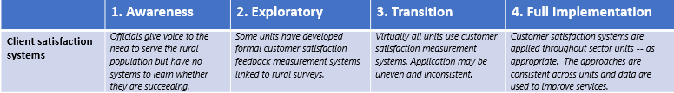

Add relevant additional methodological description

2.0 The Status of RBM Capacity in the Five Pillars and Gaps Identified
The following section presents a summary of the findings of the first and seconds stages of the AG-Scan self-assessment process and the scores assigned to the five LEAPS pillars.

2.1 Leadership
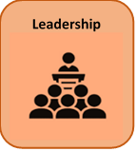
Leadership scored X.X out of 4.

Add description of results

Action Required
- xx
- yy
- zz

2.2 Evaluation and monitoring

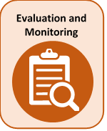
Evaluation and monitoring scored X.X out of 4.

Add description of results

Action Required
- xx
- yy
- zz

2.3 Accountability and partnership

Accountability and partnership scored X.X out of 4.

Add description of results

Action Required
- xx
- yy
- zz

2.4 Planning and budgeting

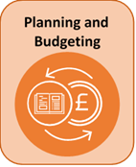
Planning and budgeting scored X.X out of 4.

Add description of results

Action Required
- xx
- yy
- zz

2.5 Statistics
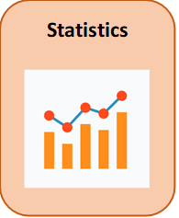
Statistics scored X.X out of 4.

Add description of results

Action Required
- xx
- yy
- zz

A summary of the scores assigned to the sub-sectors of the five LEAPS pillars during the AG-Scan are presented in Figure 2 below.

Figure 2. Summary of LEAPS Scores

Insert AG-Scan Profile

3.0 Overarching Lessons Learned (if there are lessons outside of the LEAPS results)

3.1 Insert section title

3.2 Insert section title

3.3 Insert section title

3.4 Insert section title

4.0 Objectives of the Action Plan

5.0 Proposed Interventions to Strengthen M&E and RBM
In the section which follows, activities proposed for the Action Plan in the Ag-Scan are presented according to each of the LEAPS pillars and specify whether these will be implemented in the short, medium, or longer term. The section also specifies which agencies will be responsible for implementation or funding of interventions as well as the anticipated time frames in which they will be completed.
Table 2. Interventions Proposed for the Short, Medium, and Long Term
Leadership
Short Term | Medium Term | Long Term

Evaluation and Monitoring
Short Term | Medium Term | Long Term

Accountability and Partnership
Short Term | Medium Term | Long Term

Planning and Budgeting
Short Term | Medium Term | Long Term

Statistics
Short Term | Medium Term | Long Term

5.1 Immediately Implementable Short Term Priority Interventions

Table 3: Short Term Policy Interventions
LEAPS Pillar Activity | Timeline | Resources | Estimated cost | Funding source | Responsibility /Roles | REMARKS
1. LEADERSHIP
2. EVALUATION AND MONITORING
3. ACCOUNTABILITY AND PARTNERSHIP
4. PLANNING AND BUDGETING
5. STATISTICS

6.0 Financing the Action Plan

6.1 Annual Ministerial Budgets

6.2 International Development Partners

6.3 Public-Private Partnership (PPP)

7.0 Monitoring of Plan Implementation

Annex 1: Participants List for Action Plan Workshop, day, month, year

 | Last Name | First Name | Organization | Position
1.
2.
3.
4.
5.
6.
7.
8.
9.
10.
11.
12.
13.
14.
15.
16.
17.

