**Helvetas Swiss Intercooperation / Solidar Suisse**

**Rehabilitation of Facilities of Earthquake Affected People: REAP and REAP-II**

**Final External Evaluation**

**Terms of Reference for the consulting services**

1. Background
2. Purpose and Scope of the Evaluation
3. Specific tasks
4. Method
5. Expected outputs
6. Roles and responsibilities
7. Evaluation team composition and qualifications
8. Schedule and Logistics
9. Annexes

# **Background**

Almost four years after the earthquake of April 2015, the reconstruction program continues, with hundreds of thousands of houses reconstructed, but with even more still to be completed. 812,056 households have been found to be eligible for the government reconstruction grant. The grant, 300,000 NPR, is payable in three tranches: the first (50,000 NPR) on registration, the second (150,000) on passing an inspection of construction up to lintel level; and the third (100,000) for satisfactory completion to roof level. By 18 February 2019, only 45% of the eligible households had completed construction and received all three tranches of the grant. 26% of eligible households had only received the first tranche.

The Helvetas/Solidar consortium has been implementing post-earthquake relief, recovery and reconstruction efforts in Helambu Gaupalika and Melamchi Nagarpalika, Sindupalchok District, since June 2015, shortly after the earthquake. Starting with basic emergency relief aid in the aftermath of the disaster, the consortium has implemented four SwS-funded rehabilitation/reconstruction projects, including REAP (Rehabilitation of Facilities of Earthquake Affected People), REAP-II, and E-REAP. The timeline over which these projects were implemented, along with the Helvetas ReAL project (Recovery of Agricultural Livelihoods) and the Helvetas-Caritas Schools projects (TLC and REAS), is as shown here.

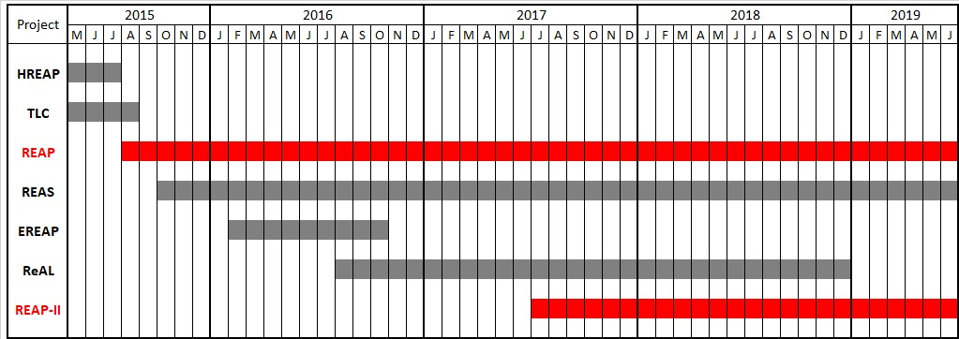

**REAP and REAP-II**

The projects under evaluation, REAP and REAP-II, are summarised as follows.

**REAP**

* Project area: Melamchi Nagarpalika and Helambu Gaupalika
* Initial proposed Outcomes:

1. 1,000 affected households are better protected through earthquake resistant permanent houses and sanitation facilities.
2. 3,000 affected households have restored access to safe drinking water.

* Modification request submitted in November 2016, subsequently approved, to allow for various changes in the implementing environment resulting from the establishment of the NRA and the national federalisation process. Several changes made, including reducing the target number of households from 1,000 to 781 for shelter assistance and from 3,000 to 2,500 for water supply.
* Request for no-cost extension of 12 months submitted in May 2018, subsequently approved by SwS. New completion date: 30 June 2019.
* Key documents:
  + Funding Application / Project Proposal, August 2015
  + Intermediate Report, November 2016
  + Modification Request, November 2016
  + Intermediate report (including request for no-cost extension), May 2018

**REAP-II**

* Project area: Four wards of Helambu Gaupalika, subsequently increased to all seven wards.
* Initial proposed Outcomes:
  + The capacities of the communities to build back earthquake-resilient, permanent houses are strengthened in 4 wards in Helambu Gaupalika.
  + The access to water supply for earthquake affected households is restored while sanitation and hygiene practices have improved.
* Modification Request submitted in April 2018, increasing Technical Assistance coverage from four wards to seven, plus three additional water supply schemes (increasing coverage from 520 households to 650). Also new target Output added for support in joint land ownership.
* Key documents:
  + Funding Application / Project Proposal, April 2017
  + Modification Request, April 2018
  + Intermediate Report, July 2018

# **Purpose and Scope of the Evaluation**

The purpose of the evaluation is to assess the Helvetas/Solidar consortium’s earthquake recovery projects (REAP and REAP-II), in terms of their relevance, effectiveness, efficiency, impact and sustainability.

Specifically:

* To identify the extent to which the projects responded to the needs and priorities of the earthquake affected people.
* To learn from experience by understanding the extent to which the projects’ interventions have worked or not, and the reasons for their successes or failures.
* To identify the strengths and limitations of the projects’ design and implementation.
* To understand better the extent to which the projects’ design and implementation processes have contributed to success or failure.
* To assess the suitability of the partnership structure and management to delivering the projects.

The target audience for the evaluation includes the implementing partners, donors, local government, the NRA, and other organizations responding to reconstruction and rehabilitation after mega disasters. It is also expected that the results of the review will be shared with the local community – both direct beneficiaries and non-beneficiaries.

# **2.1 Specific Tasks**

The evaluation covers the REAP and REAP-II projects, which started implementation (with REAP) in August 2015, and will continue (with REAP II) until the end of June 2019. The evaluation should cover the completed activities in all the projects’ sectors, including Shelter, Technical and Social Assistance, Joint Land Ownership initiative (JLO), Water Supply, Sanitation and Hygiene Promotion (WASH). A list of guiding questions follows below; it is not expected that each should be rigorously addressed, but rather that they serve to orient the evaluation team.

Relevance

* To what extent did the projects contribute to the reconstruction and rehabilitation needs of the earthquake affected people?
* To what extend did the projects adapt to the changing contexts of the country’s reconstruction policy and the reconstruction needs of the people?

Effectiveness

* How effectively did the projects identify target beneficiaries? What is the opinion of those who did not benefitted from project interventions, as well as those who did?
* Did the projects approaches result in the intended outcomes, as outlined in the project documents?
* Did the reconstruction context – including government policies and the national restructuring process – affect the project’s overall outcomes?
* How well did the projects adapt to changing conditions on the ground and new information such as survey findings?
* What adaptation measures and approaches were adopted and how useful were they?
* How and to what extent did the different project components contribute to longer term capacity building?
* Did the projects utilise innovations and best practices that are likely to be adapted for future projects?
* To what extent did the project components support the achievement of reconstruction at the local level while complementing the national reconstruction activities?

Efficiency

* To what extend did the projects achieve the targets in the given time frame?
* How did the quality of the partnership of the implementing partners and their coordination mechanisms contribute to the projects’ outcomes?
* Did the projects ensure value for money?
* To what extent did the different project components and mechanisms (shelter, technical and social assistance, WASH, JLO) complement each other?
* How did the projects manage the overall budget, administration, staff and resources in relation to the no-cost extension? How suitable were the budget, resources, staffing and administration systems in relation to the overall achievements?
* Were all the services and capacities created for affected people use appropriately?

Impact

To what extent did the project achieve the intended objectives as described in the project proposals?

To what extent did the projects add value towards realizing the rights to housing and water at the local level?

* How have the projects’ activities contributed to increased capacity to withstand and respond to future similar disasters?
* What were the most significant positive results? What, if any, were the negative results?

Sustainability

* To what extent did the projects interventions contribute towards longer term development? How sustainable are the interventions?
* How did the projects contribute to the overall livelihood framework (social, economic, financial, human and physical)?

# **Method**

* Context analysis
  + Changes in the project context
* Desk study
  + Project documents (proposals, modifications, reports)
  + Other relevant documents (such as the Accountability to Affected People report)
* Orientation
  + Interactions with key persons in Kathmandu – NRA officials, Helvetas staff
* Field visit
  + Visit project area: field offices, shelter and WASH implementation sites
  + Discussions/interviews with community members (project beneficiaries and non-beneficiaries), project staff, municipal staff (elected representatives and administrative staff), and any other stakeholders

# **Expected Outputs**

* Inception report detailing evaluation methodologies, tools and plan, within one week of signing the contract.
* Preliminary report including recommendations, in draft form, for comments and feedback.
* Debriefing meeting, including presentation of findings and recommendations to the REAP/REAP-II management team in Kathmandu.
* A final written report, not exceeding 25 pages (excluding annexes). Where possible, interesting comments made by those interviewed should be captured as quotes with the name of the person.

# **Roles and Responsibilities**

The evaluation team will be responsible for:

* Developing the evaluation methodology and a time plan that aligns to the broad time framework laid out in these terms of reference.
* Reviewing all relevant documents.
* Undertaking the evaluation as per these terms of reference.
* Presenting the draft findings to the Helvetas/Solidar consortium management team.
* Finalising the evaluation report incorporating the feedback provided.

Helvetas/Solidar Consortium will be responsible for:

* Reviewing, providing input to and approving the evaluation plan, tools and methodology.
* Providing all relevant project documents to the consultant.
* Providing an initial briefing on the projects and the expectations for this evaluation.
* Providing timely feedback to the consultant upon receipt of the draft report.
* Coordinating with responsible persons within the consortium.
* Guiding the evaluation team to field locations and providing logistical support in terms of transportation, hotel/homestay reservations, etc.

# **Evaluation Team Composition and Qualifications**

The evaluation team will be composed of two persons.

**Team Leader**

The team leader should be an international expert with at least ten years of professional experience. This experience should include project evaluation using mixed methods and work in both the humanitarian and development sectors. , Comprehensive knowledge of gender equality and social inclusion (GESI) and technical competence in WASH and/or shelter and housing would be a significant asset. S/he should have excellent English writing skills.

The team leader may be a Nepalese national or another nationality, but in the case of the former, should have appropriate experience outside the country as well as within. In the case of a non-Nepalese national, at least some experience in Nepal is strongly preferred.

**Humanitarian response specialist**

The humanitarian response specialist should be a Nepalese national fluent in the Nepali language, ideally with a professional background that complements the Team Leader in terms of WASH, shelter and housing, and GESI. S/he should have at least seven years of professional experience and be skilled in facilitating community interactions.

# **Schedule and Logistics**

The evaluation should take place in March 2019 and be finalised in April. The contract period is not expected to be longer than five weeks. The following timeline is indicative: the consultant should develop a time plan that is in alignment with it.



The tender's application should include all the expected time plan, detail and competitive budget inclusive of all costs, fees and taxes. Consultants are responsible for managing their own tax contributions.

# **Annexes[1]**

* REAP Funding Application / Project Proposal, August 2015 (Narrative, Logframe, Budget, Annexes)
* REAP Intermediate Report, November 2016
* REAP Modification Request, November 2016
* REAP Intermediate report (including request for no-cost extension), May 2018
* REAP-II Funding Application / Project Proposal, April 2017 (Narrative, Logframe, Budget, Annexes)
* Modification Request, April 2018
* Intermediate Report, July 2018
* AAP report

1. The list of documents will be provided to the selected consultant upon signing of contract